-Name of town/state :
We stay in Vasundhara, Ghaziabad which is in Uttar Pradesh. It is a planned industrial city in the Indian state of Uttar Pradesh. It is 19 km east of Delhi and 46 km southwest of Meerut. The city houses the headquarters of the Ghaziabad district. It was initially part of the Meerut district after independence, until the time when — due to political intervention — Ghaziabad was separated and given a new district status.
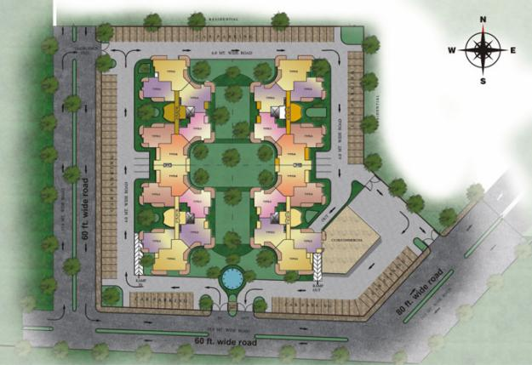
A map of our location: Vasundhara, Ghaziabad
It is a large industrial city well-connected by roads and railways. It has industries that Maintenance of electric locomotive & EMU Trains, manufacture railway Wagons, bicycles, tapestries, glassware, pottery, paint and varnish, heavy chains, etc. Also it has Bharat Electronics Limited for manufacturing defense products.
Ghaziabad is situated about 2.5 km from the Hindon River. On the north it is bound by the district of Meerut, on the south by that of Bulandshahar and Gautambudh Nagar, on the south-west by Delhi and on the east by the district Jyotibaphule Nagar. As its boundary is adjacent to Delhi, it acts as the main entrance to Uttar Pradesh and hence is also called the Gateway of Uttar Pradesh.
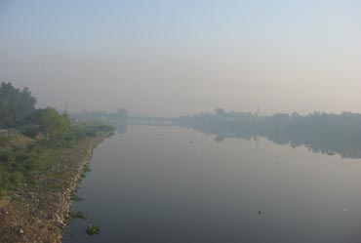
HINDON RIVER
The total area of the district (according to Census 1991) was 2590.0 km² but after the formation of the new district Gautam Budh Nagar, it becomes 1933.3 km².
Raj Nagar Extension: A high rise city developing on NH 58 Meerut road near Raj Nagar and Sanjay Nagar with all modern amenities. Raj Nagar Extension was founded by a group of Delhi NCR's more than 35 top Developers with the objective to develop Raj Nagar Extension as a flawless destination for people with aspirations for better living and within their budgets.

To meet the challenging demands of discerning customers and spot lighting the needs of esteemed customers, knowledge resource and experience of more than 35 top developers have been drawn to provide better quality and standards in living habitat at Raj Nagar Extension.
-Population : As of 2011 census, this district had a population of 4,661,452(3rd in UP) (male 2,481,803 and female 2,179,649).It contribute 2.33% of total population of UP. It has highest density (No. 1) of population in UP with 4060 persons per square km. It is second in population growth rate with 40.66%. The average literacy rate in 2011 was 85% which is highest in UP.
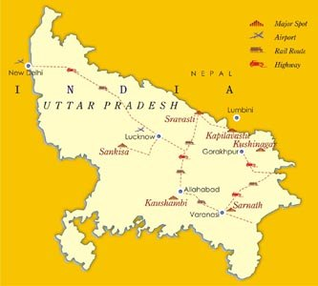

Landforms near us : Ganges, Yamuna and Hindon are the main rivers flowing through the district and they are filled with water throughout the year. Other than these, there are some small rain-fed rivers, prominent among them is the Kali river. Apart from these rivers the Ganges Canal flows through the district and irrigation work is carried out through different branches of the canal. The Ganges canal also caters to the drinking water needs of the people of Ghaziabad as well as Delhi.
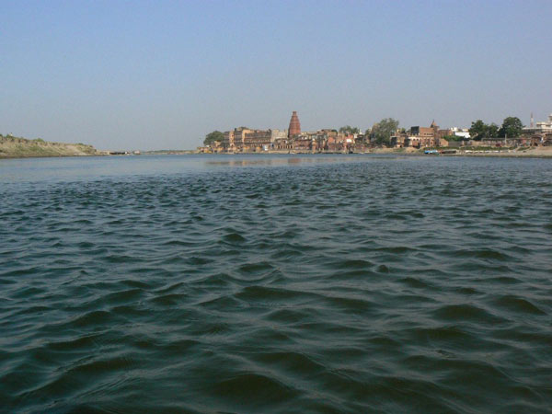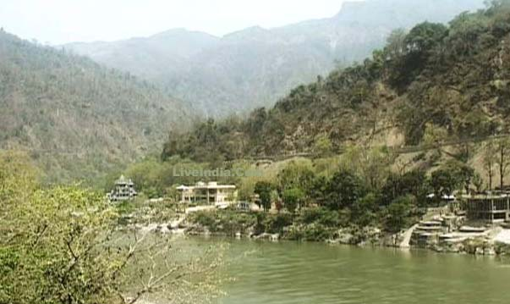
The Yamuna River The Ganges

As it is connected to National capital Delhi, its temperature and rainfall are similar to Delhi. Rajasthan's dust storms and snowfall in the Himalayas, Kumaon and Garhwal hills name their impact in the weather regularly. The monsoon arrives in the district during the end of the June or the first week of July and normally it rains until October.

As in other districts of northern India mainly three seasons- summer, winter and rainy prevail here but sometimes due to severe snowfall in the Himalayas and Kumaon Hills adverse weather can also be seen. Aravalli Hills are the oldest hills seen in our region.

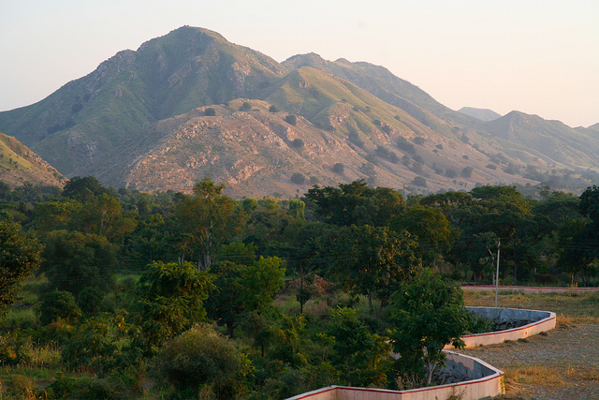

-Pictures/information about our dress, food, music, any other
cultural elements : As we have diverse culture here, so different kinds of traditional, regular and western clothes are worn by the people here.
For example: sarees, suits, trousers, T-shirts, shirts, spaghetti, kurtas etc.

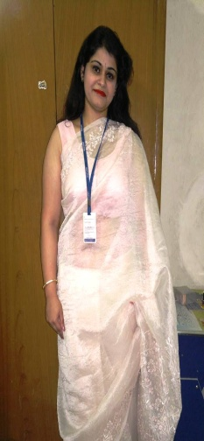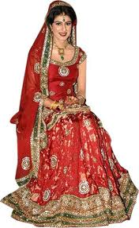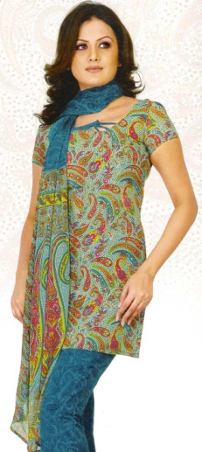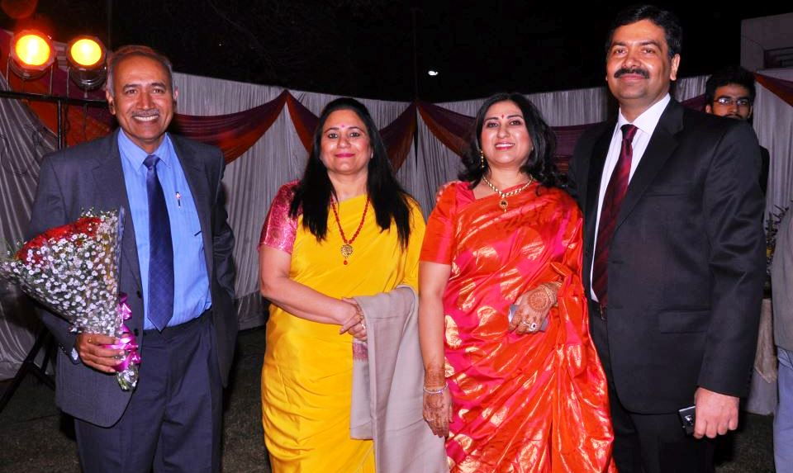

At school , students are supposed to wear their school uniform which has white shirt, grey shorts, grey socks and black shoes in summer. Their winter uniform has maroon blazer , grey trousers, white shirt with maroon tie, grey socks and black shoes. Our students also have to wear their house dress every Wednesday which has different four colours representing their houses as Ganga, Krishna, Narmada and Godawari House.
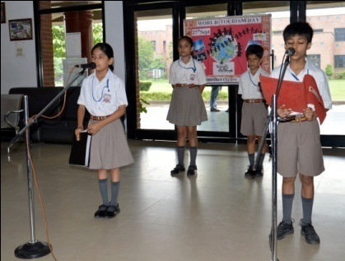

Music: We enjoy learning and listening to all kinds of music like Instrumental, classical, pop etc. There are different people of different and varied cultures. So, every individual has its own liking about music and we have a mélange of all kinds.

Food: Cuisine of community is from the state of Uttar Pradesh located in Northern India, Awadhi and Mughlai are the two chief genre of Uttar Pradeshi cuisine, and the cooking patterns of the state are similar to those of the rest of Northern India. The cuisine consists of both vegetarian and non-vegetarian dishes. Uttar Pradesh has been greatly influenced by Mughal cooking techniques. The Awadhi cuisine of Uttar Pradesh bears similarities to those of Kashmir and Punjab, and the state is

famous for its Nawabi foods(of Lucknow and environs) and use of mutton, paneer, and rich spices including cardamom and saffron. Its most famous dishes include kebabs, Dum Biryani, and various Mutton recipes. The Chaat, samosa and pakora, among the most popular snacks in all of India, are also originally from Uttar Pradesh. Awadhi is a type of West-Central Uttar Pradeshi cuisine found in the state's Awadh Region.

Popular dishes from Uttar Pradesh
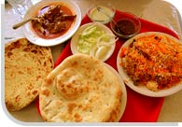

Dum Bhindi (Fried whole okra stuffed with spiced potato filling)
- Kadi Chawal
- Sultani Dal
- Shami Kabab (includes tangy green mango)
- Palak Paneer
- Samosa
- Chaat has its root from Uttar Pradesh
- Paneer Pakora & of various vegetables
- Kofta
- Tehri (vegetarian rice dish with spices and mixed vegetables that popular amongst Hindus)
- Korma
- Aaloo Paratha
- Meethi Roti
- Puri
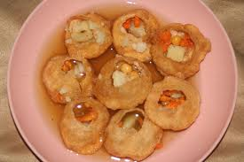
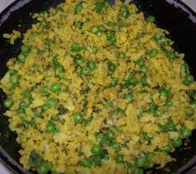
- Saada Paratha
- Shaami Kabab
- Fara
- lotpot
- lapsi
- Bariya
- Rajma, Chole,
- Boondi
- Sedha
- All List
- Gujia (like a samosa though filled with sweetened thickened milk (khoya))
- Apart from above mentioned cuisines, we also love eating Chinese, Italian, South Indian, North Indian and Mexican as well.

